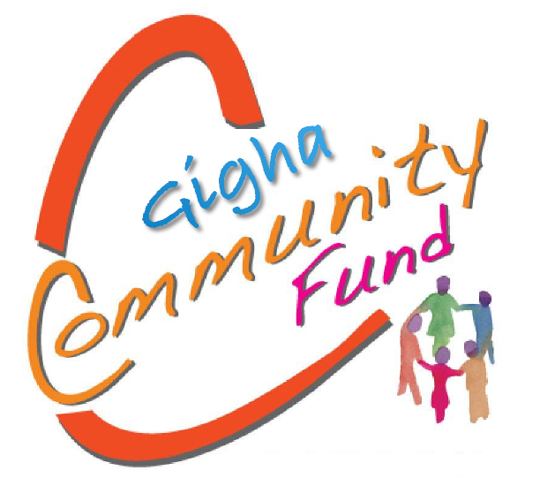

‘to support a thriving and healthy community on Gigha’
Application Form for grants up to £1000
This form should only be used if you are applying for up to £1000. Please read the associated guidance notes before completing this form. If you would like to discuss your project before applying or need help filling out the form, then please contact the IGHT Trust office. Details are given at the end of this form.
Part 1 – About you / your organisation
- What is your / your organisation’s name and contact details?
Your Name:
Your Organisation’s Name:
Address:
Postcode:
Tel: Email: Website:

- What type of organisation / community group are you?
(Community organisation/group, youth club, social enterprise, individual etc.)

If you are an individual applying, please skip to Part 2
- Do you have a constitution or set of rules setting out your aims and objectives?
Yes □ No □
DAY/MONTH/YEAR / /
- When did you organisation start?
If applicable

- How many people are on your organisation’s management committee or board? If applicable

- Are there any restrictions on who can join your organisation?
Yes □ No □
If yes, what are they and why do you have them?

7. Does your organisation have a bank or building society account with at least two signatories? Yes □ No □

Part 2 – Your Project
- Your project name:

- Tell us about your project or what you intend to use the grant for:
2.1 Outline of project (What is the project and some detail and background of what you want to do)

2.2 List the outcome(s) you expect to see from carrying out this project (the result or effect of your project). Please ensure this section is completed.
Outcomes to be covered (at least 3). Please tick all that apply and provide detail below:
- Develop skills
- Improve health
- Relieve poverty
- Protect or conserve the environment
- Engage citizens to become more active in their community
- Promote and protect the rich heritage and culture of the area
- Supporting visitor experience

2.3 If your project is part of a wider improvement/ongoing development project tell us about this?

2.5 Who within your organisation will oversee the project and take it forward to completion?

- When will your project take place?
Start date:
End date:
Please note your project must commence and all money incurred within 6 months of the start date

- Where are the people who will benefit from your project based?

- Where will your project take place?
Please enter the actual address or details the various locations it will cover.

- How much will your project cost?
You should include all costs. Please make sure costs are as accurate as possible. For grant requests over £500, please base costs on quotations where possible. DO NOT include any VAT if you can claim back from HMRC.
Item or activity | Total Cost (£) | Amount requested from Gigha Community Fund (£)
TOTAL | £ | £

- If you are not requesting 100% funding from the Gigha Community Fund, where is the remainder of your funding coming from?

- Submission
Please confirm that you have completed everything we have asked. Use the checklist below.
- I have answered all the questions in this application
- I am the main contact for the organisation and I am authorised to apply on behalf of the organisation
- I confirm that the individual / organisation is eligible to apply, as set out in the fund guidance
- Application has been signed below

Applicant signature: _________________________

Date: _________________________

Please send your completed application to: chair@gigha.org.uk
Or you can post your application to:
The Isle of Gigha Heritage Trust
Craft Workshop 1
Isle of Gigha
PA41 7AA

Contact Details:
By email: chair@gigha.org.uk or telephone: 01583 505 390

